Your name
Your address
Your telephone number
Your email address
Date
The manager/recruitment manager’s name (if you know it)
Company name
Company address

Dear Sir/Madam

Regarding: Position of 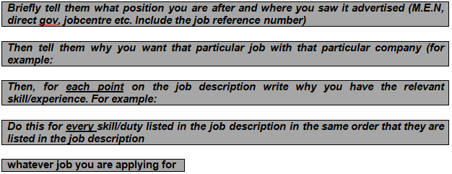

I am applying for this position because I enjoy working with people and as Morrisons is a large company with a history of excellent customer service then a career as a cashier at Morrisons will provide me with job satisfaction as well as long-term stability.

I have experience in customer service and as a cashier which I gained working for Asda. I am confident dealing with complaints and performing stock checks and work well in a team. I also have well developed supervisory skills and numeracy

I wish to disclose to you a criminal conviction for theft in 2001. The offence was a long time ago, I was young and made an error of judgement. I have not reoffended since then.

My conviction is now spent under the rehabilitation of offenders act 1974, although I am aware that I have to disclose my conviction in order to apply for this position.

I am currently working with various organisations that have not only helped me to rehabilitate myself but have also assisted me with looking for permanent employment. I haven’t been involved in any criminal offences since my conviction and now have family responsibilities and a new place to live. I feel optimistic about my future and am hoping one day to buy a home, and I know that I will never re-offend.

I hope that you will understand that my criminal past is very much behind me and that it will not affect my being considered for the position of . I thank you for taking the time to read this letter and look forward to hearing from you.

Yours sincerely

Your name

