Your name
Your address
Your telephone number
Your email address
Date
The manager/recruitment manager’s name (if you know it)
Company name
Company address

Dear Sir/Madam

Regarding: Position of 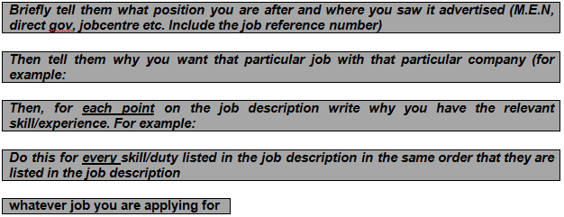

I am writing to apply for the position of Cashier as advertised on Universal Job Match reference number MA/035
I enjoy working with people and feel that because Morrisons is a large company with a history of excellent customer service then a career as a cashier at Morrisons will provide me with job satisfaction as well as long-term stability.
Your job description states that customer service and till experience is essential. I have experience in customer service and as a cashier which I gained working for Asda. I am confident dealing with complaints and performing stock checks and work well in a team. I also have well developed supervisory skills and numeracy.
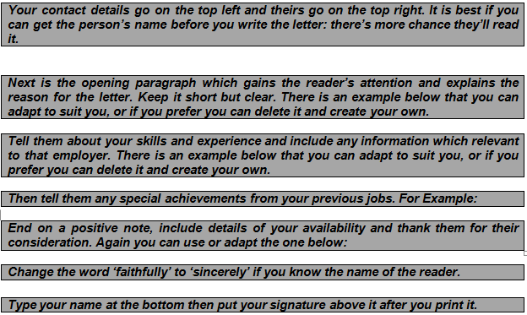
In my time at Asda I received praise from my manager and from a mystery shopper on the quality of my customer service and my product knowledge. I also maintained 100% attendance during the two years I worked in this role.
I am available for interview at any time and could start work immediately. I have enclosed a copy of my CV for your further information. I am also happy to perform a work trial to demonstrate my skills if the opportunity is available.

I thank you for taking the time to read this letter and look forward to hearing from you.
Yours faithfully

Your name

