Your name
Your address
Your telephone number
Your email address
Date

The manager/recruitment manager’s name (if you know it)
Company name
Company address

Dear Sir/Madam
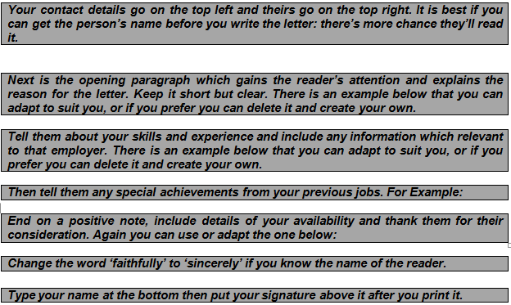
I am writing to you because I wish to gain experience in catering and am seeking a voluntary position / placement. I would like to offer your organisation my services on an unpaid basis.

For the past two years I have been in the home caring for my child / relative / partner, a role that has required excellent time and budget management skills, health & safety and food hygiene awareness, all of which will benefit me in a catering role.
I have performed work experience placement in retail and customer service at Next, where I was responsible for taking deliveries, performing stock checks and merchandising. Through this experience I developed excellent attention to detail and the ability to work quickly and accurately, skills I feel will be essential in catering. As this was a short-term placement it required me to be a fast learner and integrate within a new team quickly.
I am able to work up to X days / hours per week and am available on Mondays / Tuesdays / Wednesdays / Thursdays / Fridays / Saturdays / Sundays. I have enclosed a copy of my CV for further information.

I thank you for taking the time to read this letter and look forward to hearing from you.
Yours faithfully

Your name

