Your name
Your address
Your telephone number
Your email address
Date

The manager/recruitment manager’s name (if you know it)
Company name
Company address

Dear Sir/Madam
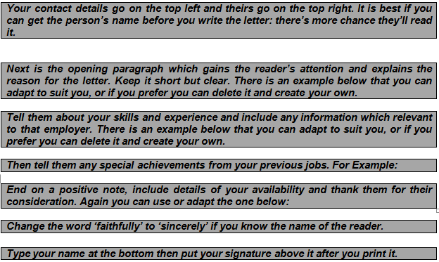
I am writing to you because I am seeking employment as a retail assistant and was wondering if you have any current or upcoming vacancies for someone with my skills.

I have experience in customer service and as a cashier which I gained working for Asda. I am confident dealing with complaints and performing stock checks and work well in a team. I also have well developed supervisory skills and numeracy.
In my time at Asda I received praise from my manager and from a mystery shopper on the quality of my customer service and my product knowledge. I also maintained 100% attendance during the two years I worked in this role.
I am available for interview at any time and could start work immediately. I have enclosed a copy of my CV for your further information. I am also happy to perform a work trial to demonstrate my skills if the opportunity is available.

I thank you for taking the time to read this letter and look forward to hearing from you.
Yours faithfully

Your name

